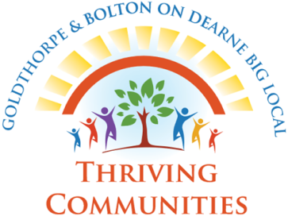 BIG LOCAL COMMUNITY SMALL GRANTS SCHEME
APPLICATION FORM
1) | Name of your group or organisation  Please tell us the group or organisation name as it appears on your governing document, this is likely to be a constitution. This name must match your bank statement and accounts.
2) | Name of your project  Chose a short title that best describes your activities for this project.
3) | Tell us about your project  Please give a brief description of your project that you want us to fund and be specific about what the funding will pay for and who will benefit from the project.
4) | What evidence is there that shows this project is needed?
5) | Please tell us a little about your organisation  Tell us what your organisation does and who it involves. Tell us about your members, who they are and where they come from.
6) | Project costs and grant needed  Please fill in this table giving the total cost of each item and how much funding you need from us.  Item Cost Other funding Big Local contribution  Total £

7) | Contact details  Please give the contact details of two people we can contact if we have any queries about this application.  Main Contact  Name:  Address:  Post code:  Telephone:  Email:  Second Contact  Name:  Address:  Post code:  Telephone:  Email:

Authorisation

- I understand that any award given must be spent as itemised within this application. Any changes must first be approved by the Big Local Partnership Board.

- I understand that my organisation must provide receipts and any monitoring information required by Goldthorpe and Bolton on Dearne Big Local.

Signed: Date:

Name: (please print)

On behalf of: (name of organisation)

8) | Bank Details  We pay successful applicants using an electronic transfer, which means the money goes direct to your organisations bank account. Please attach your most recent bank statement or photocopy of a passbook with this application.  Name of Account:  Account sort code:  Account number:  Name, address and post code of bank:
9) | Signatories  To be eligible for your grant your account must require at least three signatories for the release of funds. Please list everyone who is authorised to sign cheques drawn from this account.  Name:  Position in organisation  Name:  Position in organisation  Name:  Position in organisation
Please return your completed form to: Goldthorpe.bolton@cpruk.net
Or telephone 07879 739043 to arrange collection
Remember to include the following:
- A signed copy of your organisations constitution or governing document
- Most recent bank statement (or income and expenditure statements for organisations less than twelve months old)
- An original bank statement (or photocopy of building society pass book)

